**PROJECT NO:2 MY SQL**

1. Retrieve the book title, category, and rental price of all available books.

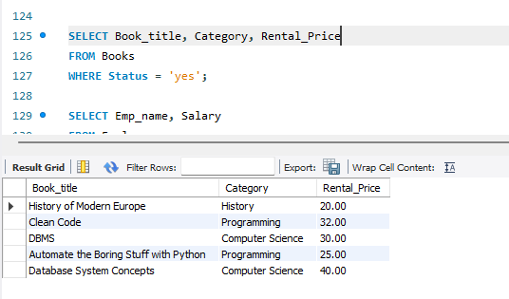

2. List the employee names and their respective salaries in descending order of salary.

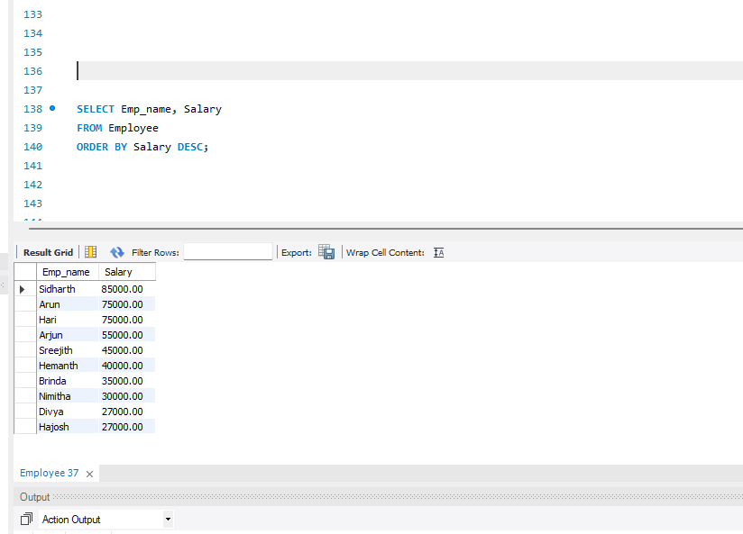

3.  Retrieve the book titles and the corresponding customers who have issued those books.

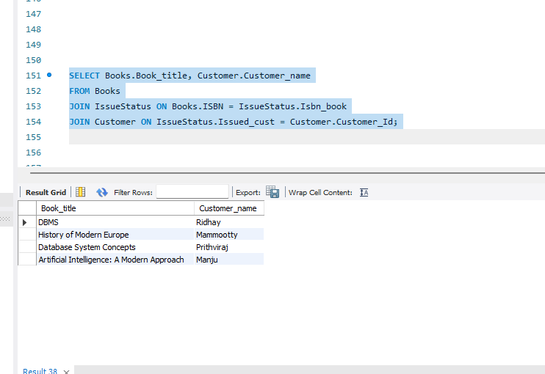

4.  Display the total count of books in each category.

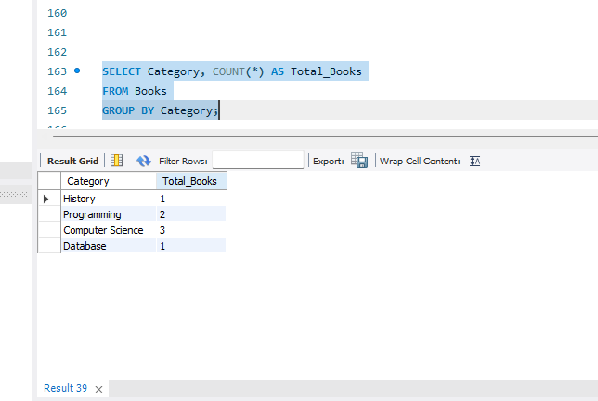

5.  Retrieve the employee names and their positions for the employees whose salaries are above Rs.50,000.

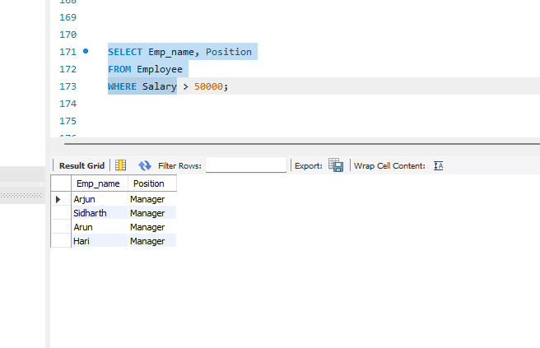

6. List the customer names who registered before 2022-01-01 and have not issued any books yet.

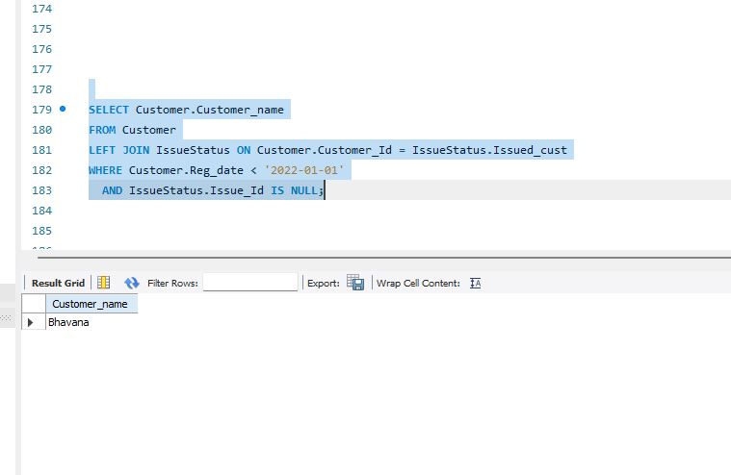

7. Display the branch numbers and the total count of employees in each branch.

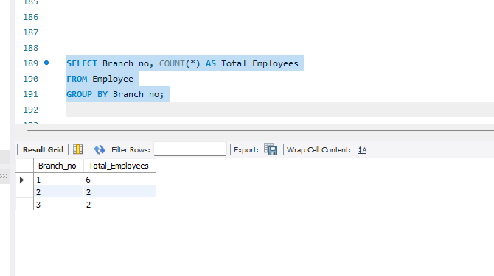

8. Display the names of customers who have issued books in the month of June 2023.

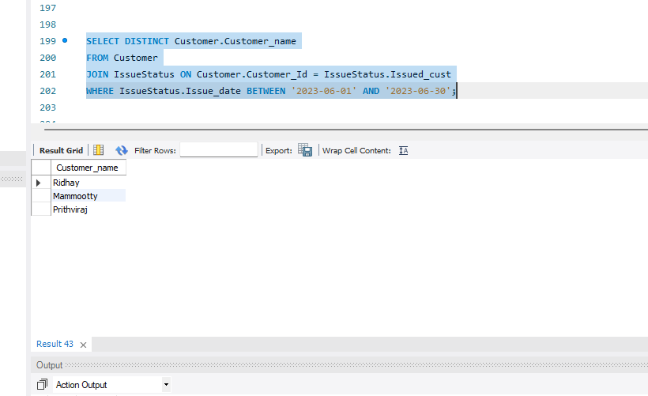

9. Retrieve book_title from book table containing history.

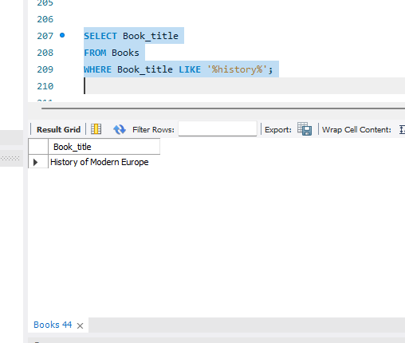

10. Retrieve the branch numbers along with the count of employees for branches having more than 5 employees

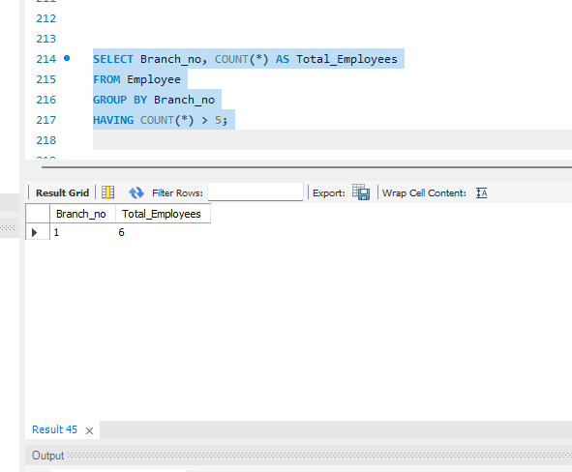

11.  Retrieve the names of employees who manage branches and their respective branch addresses.

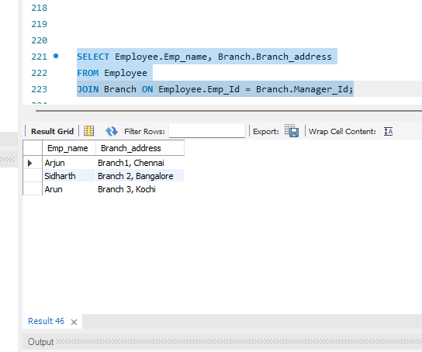

12.  Display the names of customers who have issued books with a rental price higher than Rs. 25.

